Where Excellence is a Standard and Flight Safety Comes First!
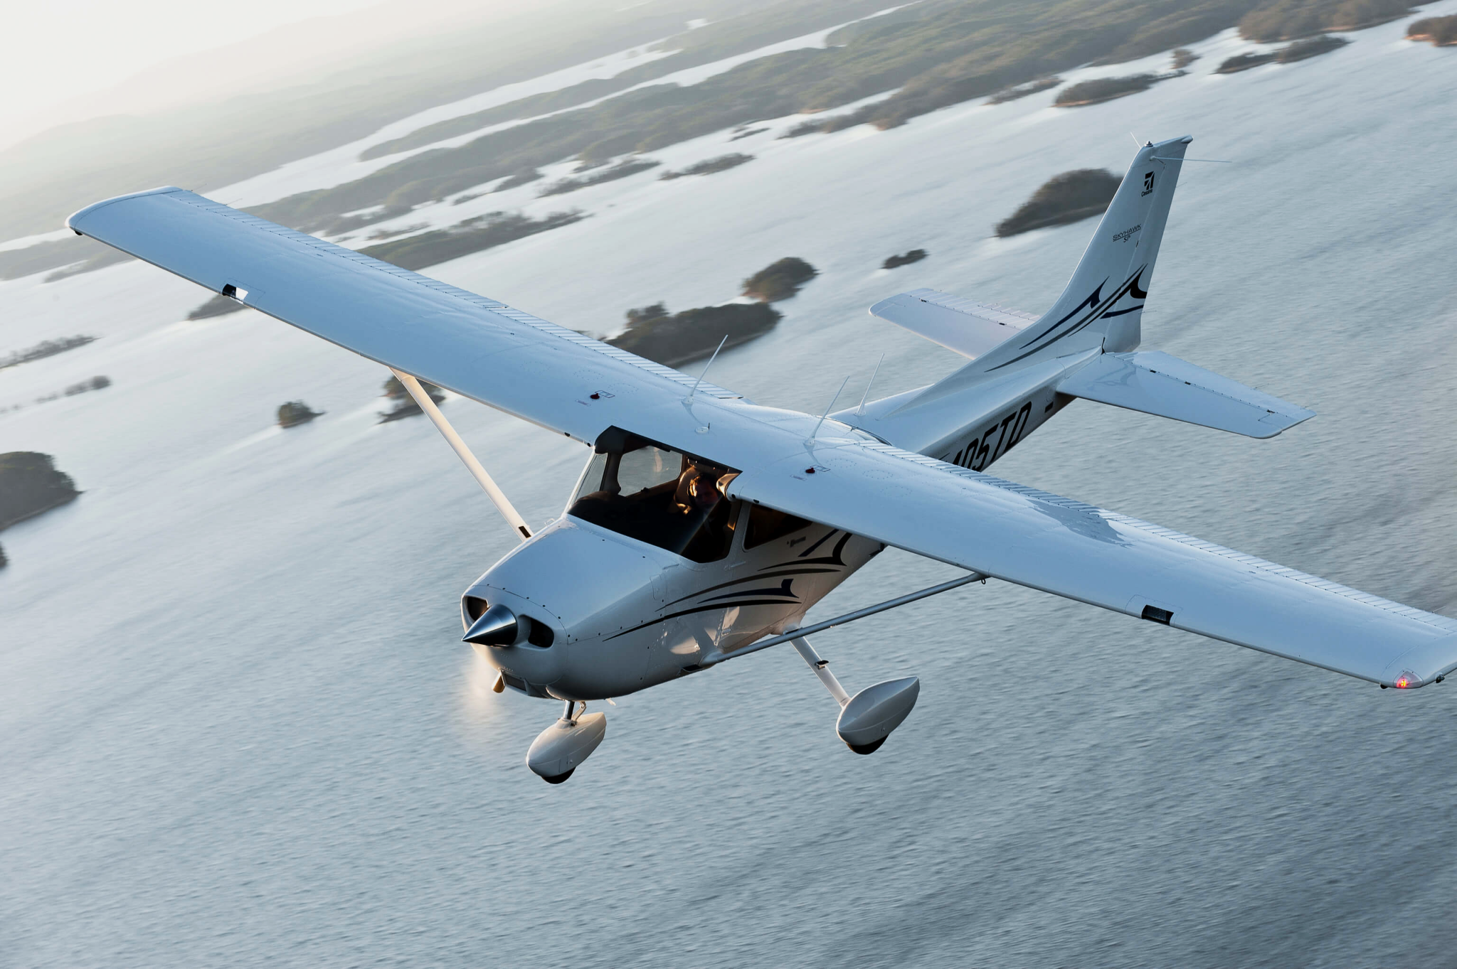

Orange County Flight Center
Domestic Student Catalog

Orange County Flight Center, Inc.
John Wayne Airport Campus.
19531 Campus Drive, Suite No. 4
Santa Ana, California 92707
Dispatch: (949)756-1300
Main email: info@ocfc.com
www.ocfc.com
Dear Student,

Welcome to Orange County Flight Center (“OCFC”), one of the oldest flight schools in California, established in 1981, and located at John Wayne Airport, Orange County. This pioneer pilot training institution was established to fulfill the growing need for well-trained and qualified aviators in the United States and to sculpt tomorrow's aviation professionals for both ground and flight opportunities within and outside of the United States.
Now is the best time to be qualified as an airline pilot. As of today, over 80,000 pilots over the age of 65 are retiring or approaching mandatory retirement. With this aging workforce, demand within North America alone exceeds 128,000 pilots. Pilot training today faces a bright future with increasing demand for travel and record numbers of passengers. Competition for qualified pilots will remain strong over the next few years and airlines will need to hire over 10,000 pilots to keep pace with the growth in the aviation sector.
Our well- trained and supervised flight instructors and other staff at OCFC are here to assist as you become engaged as an aviation professional and launch a career within the commercial aviation industry. We take great pride in your success and are able and willing to provide you with the time, attention and support needed for success. Your journey to this exciting career as an airline pilot begins now. This is just the beginning of your lifetime opportunities within the aviation sector and we at OCFC welcome you to become a part of our culture and look forward to launching you into aviation.
On behalf of Orange County Flight Center, where excellence is a standard and flight safety comes first, we welcome you and wish you success.

The OCFC Team

OCFC Program Hours & Fees
Pricing allows use of any Cessna 172 aircraft in our fleet
Program I
FAA Minimums
Private Pilot |  |  |  |  |  | Commercial License
Part 61 |  |  | Instrument Rating |  |  | Part 61
30hr Dual |  |  | Part 61 |  |  | 20hr Dual
10hr Solo |  |  | 40hr Dual |  |  | 10hr Solo
Total Cost: |  |  | Total Cost: |  |  | Total Cost:
$12,550.00 |  |  | $13,600.00 |  |  | $9,400.00
Program II
Cessna Pilot Course
Private Pilot |  |  |  |  |  | Commercial License
Part 61 | Part 141 |  | Instrument Rating |  |  | Part 61 | Part 141
30.3hr Dual | 28.8hr Dual |  | Part 61 | Part 141 |  | 20hr Dual | 55hr Dual
10.1hr Solo | 7.5hr Solo |  | 40hr Dual | 35hr Dual |  | 10hr Solo | 65hr solo
25.6 ground | 25.6 ground |  | 24.5 ground | 24.5 Ground |  | 26.7 ground | 26.7 ground
Total Cost: | Total Cost: |  | Total Cost: | Total Cost: |  | Total Cost: | Total Cost:
$14,851.00 | $13,699.00 |  | $15,805.00 | $14,105.00 |  | $11,936.50 | $37,761.50
Certified Flight Instructor |  |  | Certified Flight Instructor Instrument |  |  | Multi-Engine Rating
Part 61 | Part 141 |  | Part 61 | Part 141 |  | Part 61 | Part 141
25 hr Dual | 25 hr Dual |  | 15hr Dual | 15hr Dual |  | 15hr Dual | 15hr Dual
16.3 ground | 16.3 ground |  | 12.8 ground | 12.8 ground |  | 17.7 ground | 17.7 ground
Total Cost: $9,967.00 |  |  | Total Cost: $6,252.00 |  |  | Total Cost: $9,862.50

*Program III
Full Payment & Financing Options
Private Pilot |  |  |  |  |  | Commercial License
Part 61 | Part 141 |  | Instrument Rating |  |  | Part 61 | Part 141
Use part 141 syllabus totals | 55hrs Dual |  | Part 61 | Part 141 |  | Use part 141 syllabus totals | 58hrs Dual
Use part 141 syllabus totals | 10hrs Solo |  | Use part 141 syllabus totals | 47hrs Dual |  | Use part 141 syllabus totals | 63hrs Solo
Use part 141 syllabus totals | 35 Ground |  | Use part 141 syllabus totals | 22hrs Ground |  | Use part 141 syllabus totals | 27hrs Ground
Total Cost: |  |  | Total Cost: |  |  | Total Cost:
$23,900.00 |  |  | $17,960.00 |  |  | $38,325.00
Certified Flight Instructor |  |  | Certified Flight Instructor Instrument |  |  | Multi-Engine Rating
Part 61 | Part 141 |  | Part 61 | Part 141 |  | Part 61 | Part 141
Use part 141 syllabus totals | 26hrs Dual |  | 9hrs Dual | None |  | 18hrs Dual | None
Use part 141 syllabus totals | 74hrs Ground |  | 16hrs Ground | None |  | 16hrs Ground | None
Total Cost: |  |  | Total Cost: |  |  | Total Cost:
$15,500.00 |  |  | $4,500.00 |  |  | $11,180.00
*Program III is ONLY for students receiving financing or who wish to pay a lump sum up front

Pay As You Go Rate Sheet

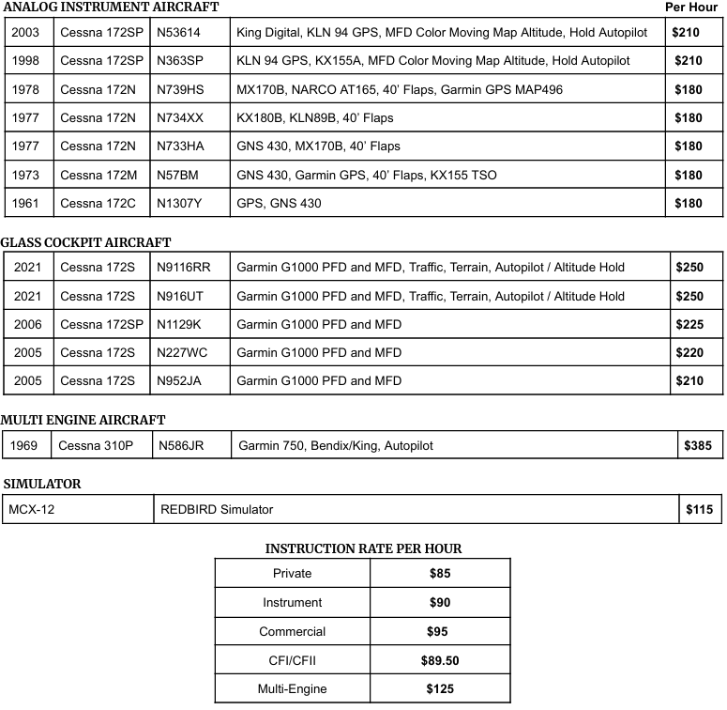
Effective 03/10/2026

Discounts & Credits for Pay as You Go Students

Block Rate Credits “BRC”
Block Rate will be defined as discount credits made available only to students who are committed to completing their training program AND make payments in blocks of $1500.00 or more in increments of $500. A 10% Block rate discount credit will be issued on each $1500.00 or more block payment. Credits are applied towards Aircraft rental and Instruction charges described in the Pay as You Go rate sheet. Block rate discount credit is applied towards program completion only and any unused portion of funds paid and credited must be flown off. There will be no refund of block rate credit issued under any circumstances as such discount credits are only offered to those students intending to complete the program they are signed up for and do not represent any cash value.

Block rate credits cannot be applied to negative accounts. Any monies paid should first be applied to bring an account to positive or zero and only after which a student will be eligible for “BRC”.

Education Discounts & Course Completion Discount Credit
(These are 5% discounts applied to eligible accounts ONLY after 40 hours of flight time has been completed and are only applied to the money already spent on those 40 hours)

Active School & College Students
- You must be an active student at an accredited high school or college and a current student ID must be presented to receive the discount
Women in Aviation
- You must be a current, active member in any of the following organizations
- The Ninety Nines
- Girls with Wings
- Women in Corporate Aviation
- Civil Air Patrol
- Women in Aviation
- The International Society of Women

U.S. Active & Veteran Military/Law Enforcement/Fire Department
- If you are an active/current employee of any state, federal, county or city law enforcement including but not limited to Active duty members of the U.S. Military; Members of the Reserve component when serving on active duty; Members of the National Guard; Active duty commissioned officers of the Public Health Service or the National Oceanic and Atmospheric Administration, Police or Sheriff’s department, Fire Department, U.S. Marshall, U.S. Veteran you are eligible for this discount

Course Completion Discount Credit “CCDC”
- A discretionary 5% Course Completion Discount Credit “CCDC” will be credited to an account after an enrolled student completes 40 hours of flight training. “CCDC” is a course completion credit and is not redeemable for cash, checks or refunds and is issued at the discretion of OCFC. In the calculation of “CCDC” the actual monies spent by the student towards any flight training programs offered by OCFC is taken into account. This does not include any block rate credits given to any enrolled student. Meaning that “CCDC” equals 5% of all Cash/Check/Card payments made by an enrolled student

Please Note:
In order for any student to avail themselves of any discounts and discount credit offered, their account should be in good standing at all times, meaning the student’s account cannot have a negative balance at any time during training

All education discounts are credited to individual accounts based upon fees actually paid and spent at the completion of 40 hours of training only. Furthermore, any discount offered by OCFC, whether written or verbal, is not an obligation but at the sole discretion of OCFC.

Non-Tuition Related Expenses

Cessna King School Syllabus | $424.00
Fingerprinting | ~ $100.00
TSA Registration | ~ $130.00
Medical Exam | ~ $150.00
Designated Pilot Examiner Fees | ~ $800 - $1200 per check ride
FAA Written Exams | ~ $175.00 per exam
Enrollment Fee | $250
Enrollment Down Payment | $2500 (goes towards flight account)
*The prices listed above are approximate and are subject to change

Path to the Airlines
Private Pilot License
Instrument Rating
Optional add ons recommended for time building
Commercial Pilot license

Certified Flight Instructor
(not required but recommended for time building)

Multi – Engine Rating

Certified Flight Instructor - Instrument
Airline Transport Pilot (ATP)
Achievable at 1500 hrs. or 1000 – 1250 hrs. for R-ATP

The Enrollment Process

- Step One: Determine if you qualify
- Are you at least 16 years of age?
(Can be 16 to solo, must be 17 to be licensed)

- Can you speak, read, write and understand English?
If the answer to these questions was “YES” then proceed to step 2!
- Step Two: Determine which program best suits your needs

- Part 141 or Part 61? We are a FAA approved 141 school, but we offer both programs depending on your discipline level and learning style
- Part 61 = flexible, self-paced learning, allowing you to mix & match lessons rather than following syllabus progression exactly, this part follows the same part 141 syllabus, stage checks are not required for progression through the course
- Part 141 = Rigid structured learning, follows the syllabus to a tee, stage checks along the way set small goals throughout training, making the overall goal of completion less daunting, Part 141 is required for a restricted ATP rating and recommended for aspiring airline pilots

- Step Three: Come in and fill out enrollment paperwork with our dispatch team

- Step Four: Pay your program in full or place a down payment and enrollment fee
We are invested in your success and completion of your program, while our prices are firm, we have flexible payment options for every budget and plenty of promotions or discount options that may be right for you

- Step Five: Start Training!

Once you have signed up and are ready to go, we will get you assigned an instructor and get you started on your aviation journey!

Where Excellence is a Standard and Flight Safety Comes First!

Domestic Student Admission Application Form

Program of Study:
- Airline Pilot Program ○ Airline Transport Pilot (ATP)
- Private Pilot Certificate ○ Instrument rating ○ Commercial License
- Multi‐Engine‐Private ○ Multi‐Engine‐Commercial
- Certified Flight Instructor ○ Certified Flight Instructor‐Instrument.
- 40-hour Private Pilot Certification Challenge

Personal Information:
First Name: ______________________ Middle Name: __________________
Last Name: ______________________ Date of Birth: _______________
U.S. Citizen? Yes: ____ No: ____
Address: ___________________________________________________________
E-Mail: ____________________________________________________________

How did you hear about our school: ○ OCFC student ○ Newspaper
- Social media__________ ○ Radio/TV ○ Internet ○ Flight
- Family/Friend _________ ○ Magazine ○ Website
- USA Overseas Info Center ○ Educational Fair/School Visit
- Other (please specify) ______________________________________________

I certify that I have carefully considered each question above and that my statements are true and complete to the best of my knowledge. By signing on this line, I understand and acknowledge that I must attend and complete the flight training program into which I have enrolled.

Date: ___________________ Applicant’s Signature: _______________________

Submission of Application for Admission

Please attach and submit the following fees/document(s) along with this Student Admission Application form:
- Enrollment/Application processing fee
- Copy of a driver's license and a copy of a valid passport or another government issued ID
- Copy of Aircraft Renters Insurance
- Copy of aviation medical certificate (if already completed)
- Copy of Pilot certificate (if already completed)

